**OSINT exercise #001 (Gralhix):**

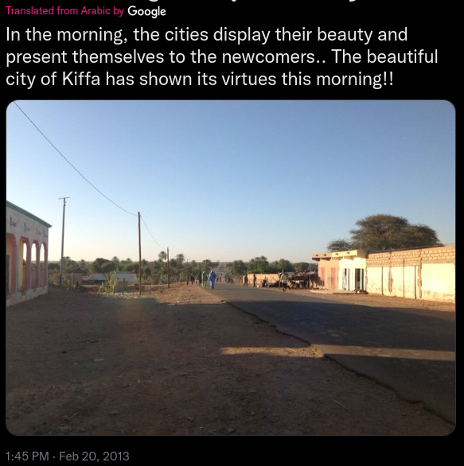

The post states that the picture was taken in Kiffa. Google maps shows there is a city called Kiffa in Mauritania. When performing a Google reverse image search, one of the results from travelplanner.app (Figure 1) shows a very similar image with the subtext ‘Kiffa, Mauritania: things to do, see information’, confirming that the picture is indeed taken in Kiffa, Mauritania. Looking closer at the picture, the location is suggested to be at the edge of the city, facing away from the city. A paved road can be seen as well as a cluster of trees. Going back to Google maps and looking at the terrain layer, there is only one main road that is on the outskirts of the city going through a cluster of trees (Figure 2). Unfortunately, Google street view has no data for this location. I opened Google Earth Pro and searched for this location with satellite images from the year 2013. Zooming into this location and lining up the perspective to the provided image, we can see some individual trees that look similar to the ones seen in the provided image. There is also a path going to the left, which also looks like the one in the provided image. Sliding some more through the timeline, shadows pop up from the electricity poles, which can also be seen on the provided image.

The location of the image thus seems to be 16.60957325980305, -11.39789362587661.